Activity 1.3.2: Student Resource Sheet

Normal Hearing | 0-20 dB
Mild Hearing Loss | 21-40 dB
Moderate Hearing Loss | 41-55 dB
Moderate to Severe Hearing Loss | 56-70 dB
Severe Hearing Loss | 71-90 dB
Profound Hearing Loss | >90 dB

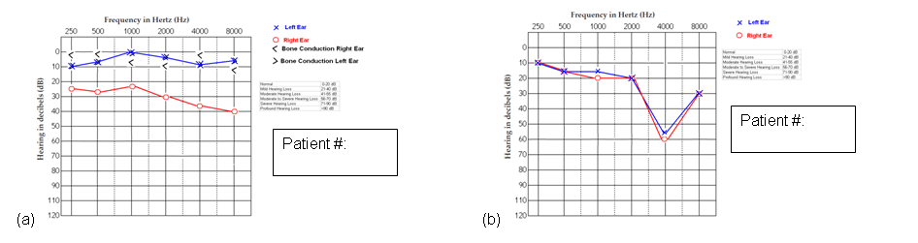
1
2
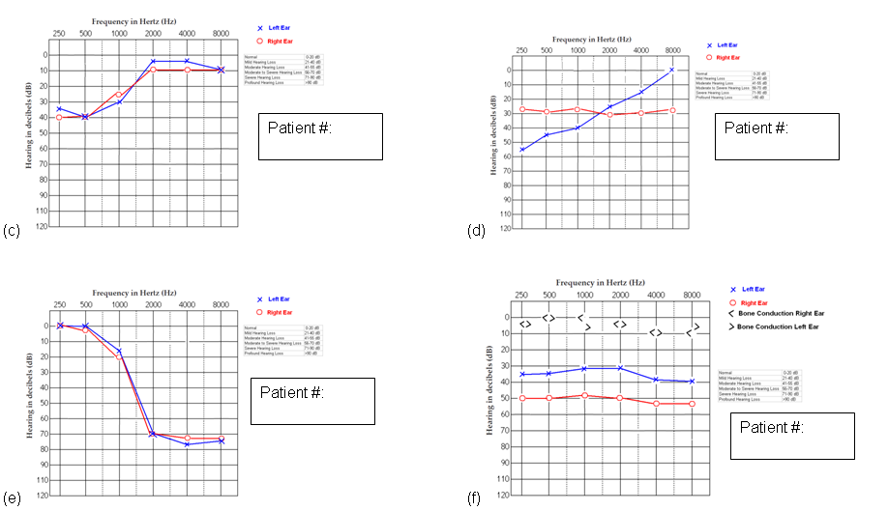
100
5
8
4
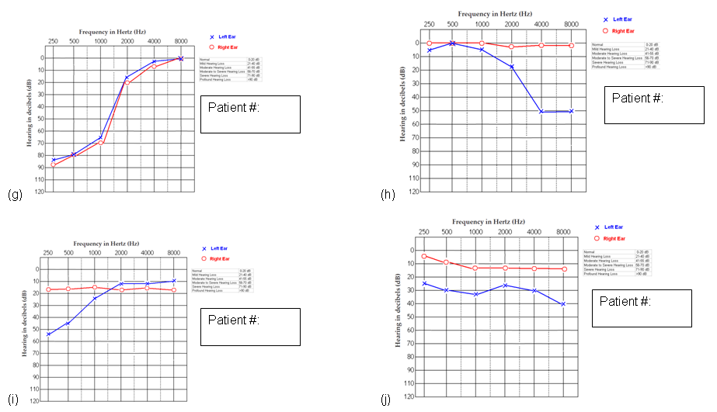
9
3
7
6

