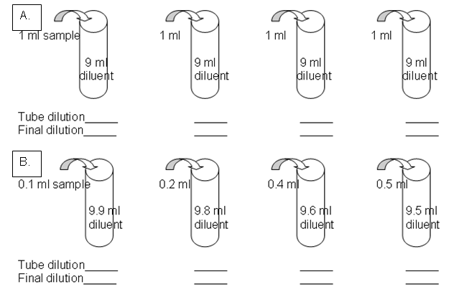

1/50 1/25 1/20

1/5000 1/125,000 1/2500000

1/100

1/100

1/100

1/10,000

1/1000

1/10

1/10

1/10

1/10

1/10

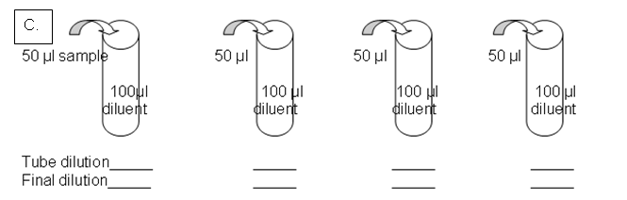

1/3 1/3 1/3 1/3

1/3 1/9 1/27 1/81